Module 4: VPC Assignment – 1

1. Created VPC

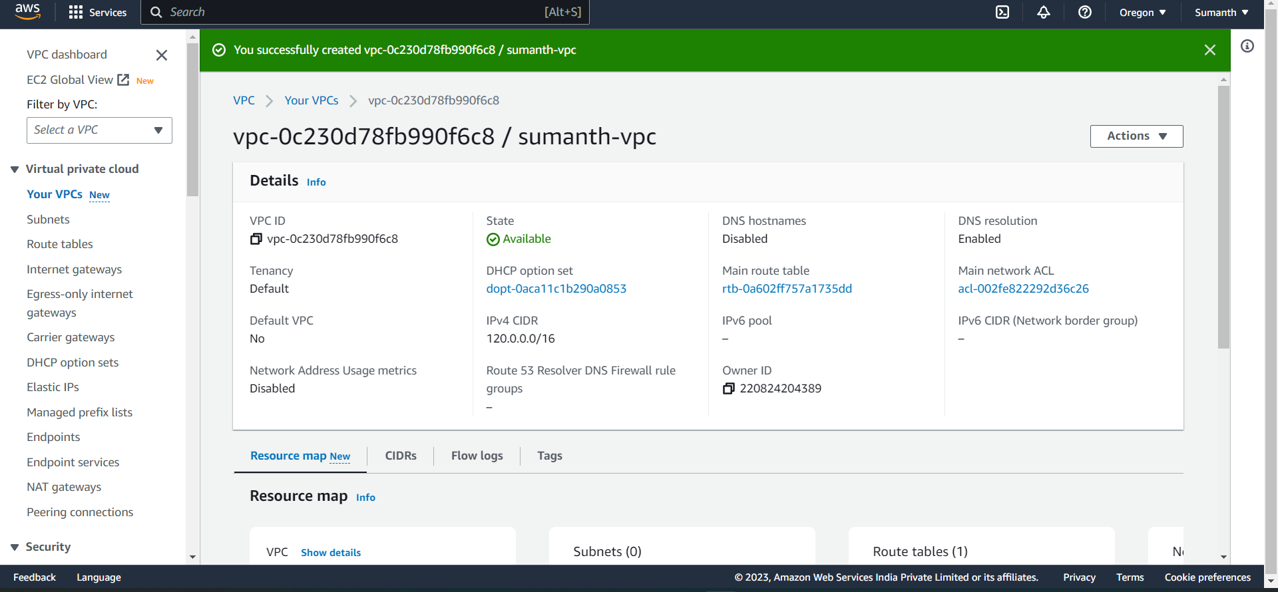

1. Created 1 Public subnet and 2 Private subnet

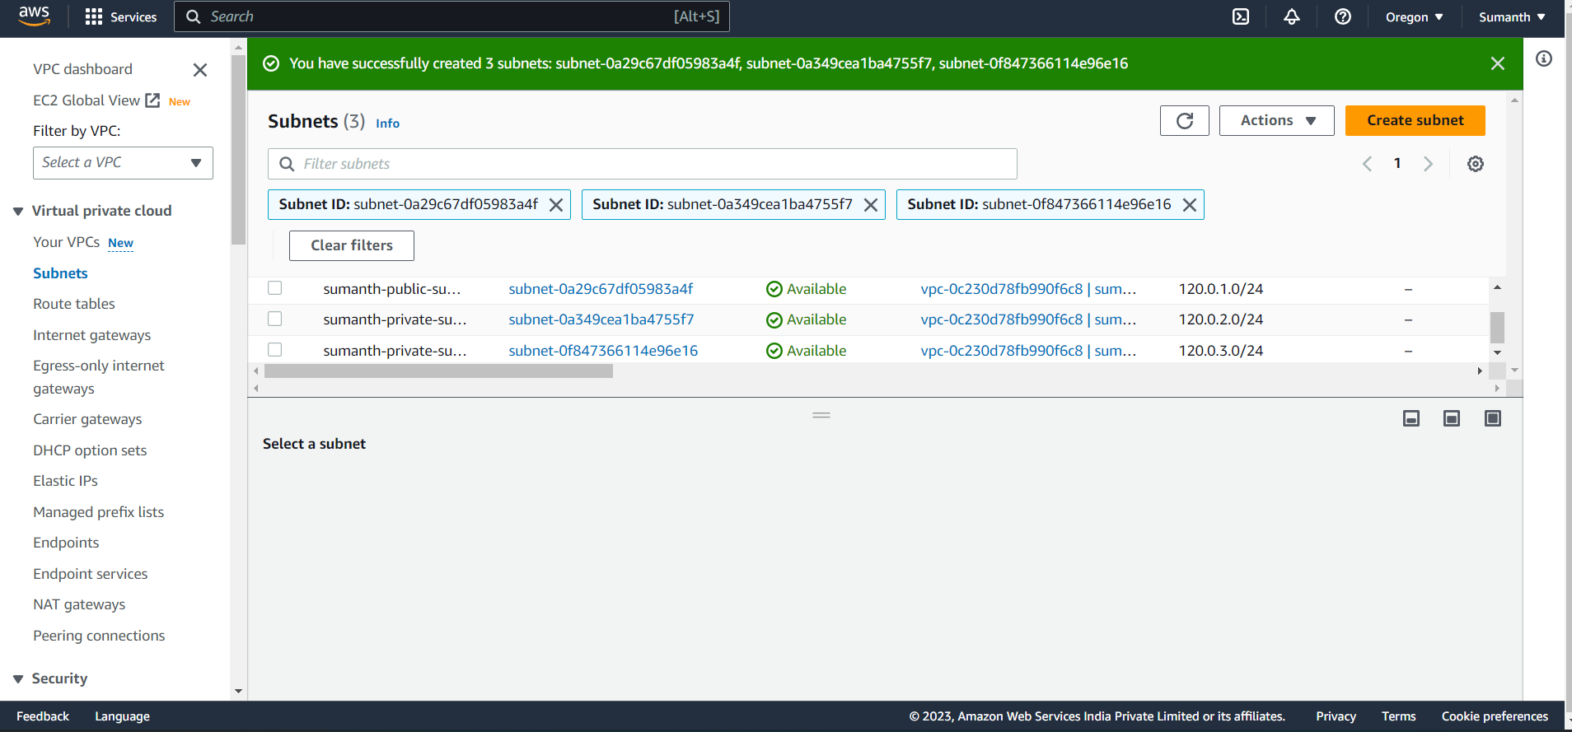

1. Created an Internet Gateway

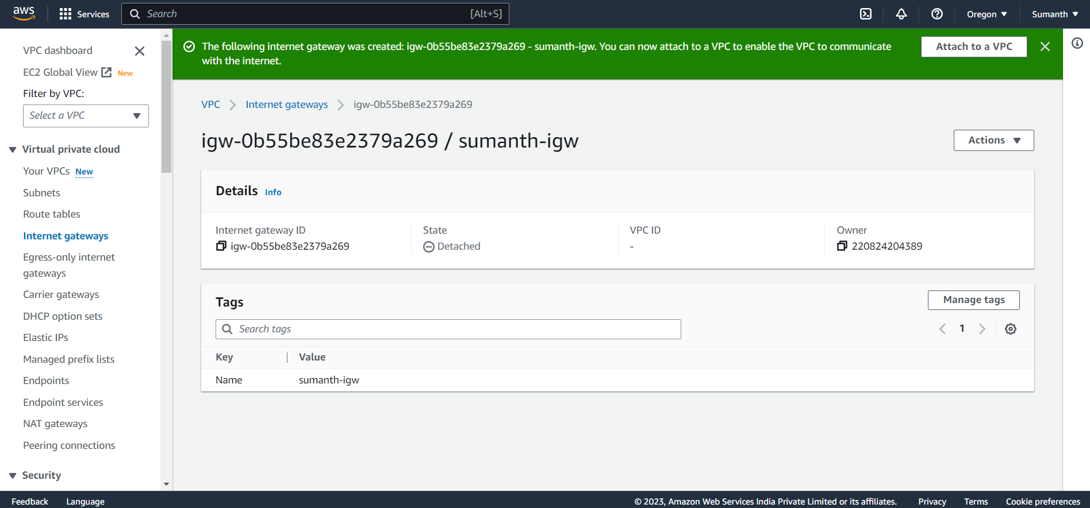

1. Attached Internet Gateway to my VPC

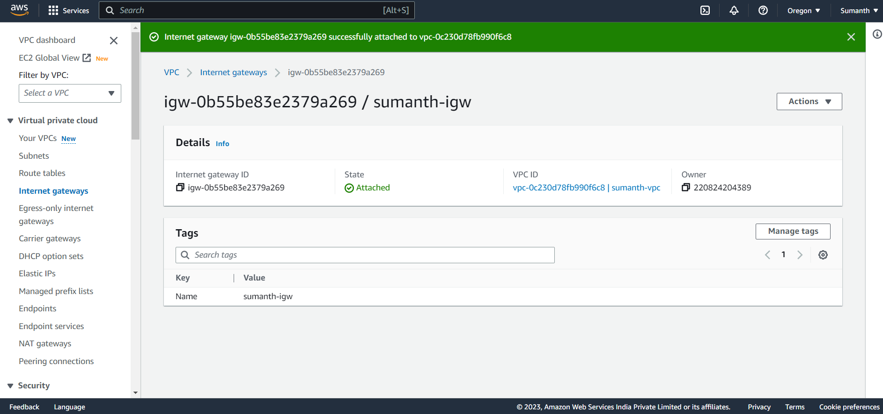

1. Created a Route table with IGW and associated the subnet with my Public subnet

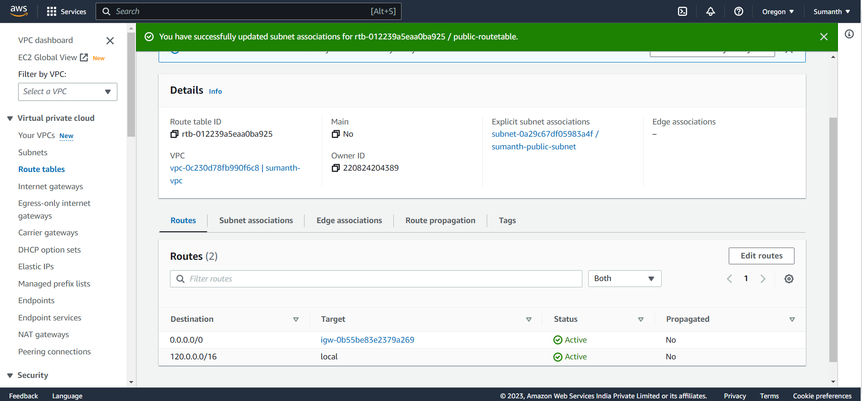

1. Created a Route table with Nat gateway & associated the subnet with my private subnets 1&2 (We have to connect the Nat gateway to public subnet and we connect to private subnet through public subnet).

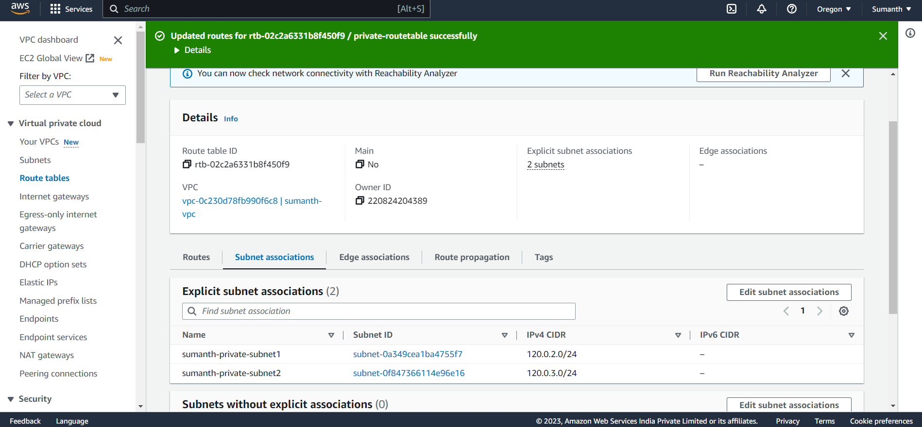

1. Created 3 EC2 instances on 1 public subnet and 2 private subnets

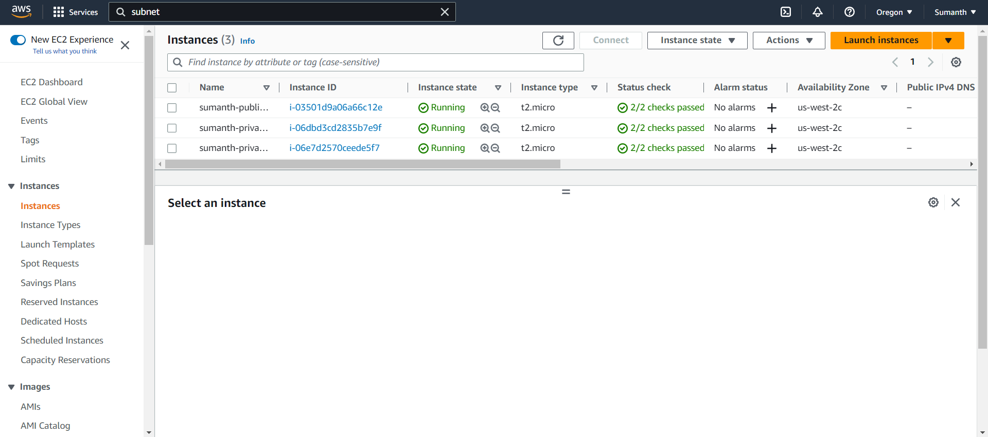

1. Internet connectivity for Private subnet 1

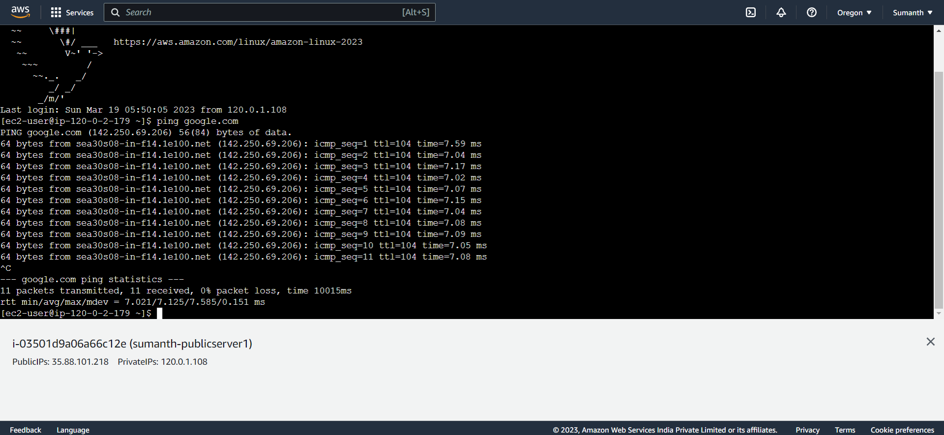

1. Internet connectivity for Private subnet 2

